Wolf/Moose Population Analysis
Name: Date: Period:

Background: Isle Royale National Park on a remote island was established in 1940, and designated a wilderness area in 1976. The only mode of transportation available is by boat or seaplane. Moose first arrived at Isle Royale around 1900. The moose population tends to increase in years with mild winters, early spring green-up, abundant winter forage, low wolf numbers and low levels of tick infestation. Wolves first arrived at the island on an ice bridge from Canada in 1940. Disease has also influenced the wolf population. Between 1980 and 1982, the wolf population declined from 50 to 14, due to canine parvovirus.
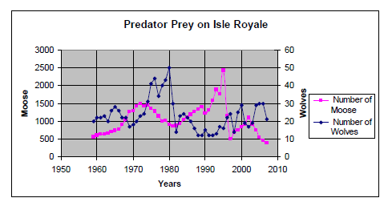
- How did the Isle Royale wolf population change between 1977 and 1980?
- How did the moose population change during that same period?
- How did the wolf population change between 1986 and 1988?
- How did the moose population change during that same period?
- Describe the pattern between the wolf (predator) population in relation to the moose (prey) population.
- What is the greatest moose population? What year did that occur?
- What was the wolf population when the moose population the greatest?
- What would happen to the wolf population if the moose population decreases?
- What would happen to the moose population if the wolves were removed from Isle Royale?
- Identify a limiting factor, other than moose population, that has influenced the wolf population in Isle Royale.
- Identify two limiting factors, other than the wolf population, that may influence the moose population.
- Isle Royale has been undeclared as a national park and has been purchased by a large resort. Describe one positive and one negative impact on the Isle Royale ecosystem.

