I. Define:
Wind-
Anemometer-
Wind-chill factor-
Coriolis Effect-

II. Explain:
What causes winds?
What is the difference between local winds and global winds?
What is the difference between land breeze and sea breeze?
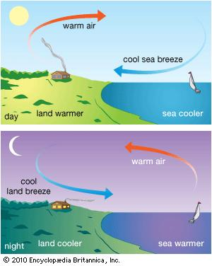
Label the diagrams:

III. Global Wind Pattern Questions
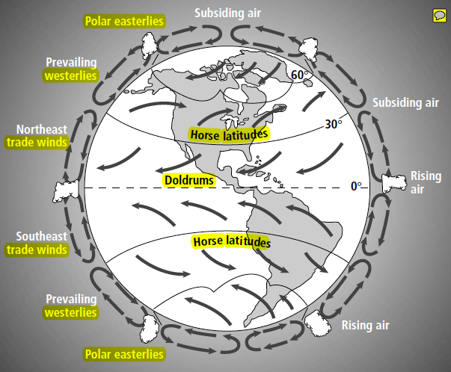

- What wind systems move air from about 30* north or south latitude toward the equator?
- Describe the movement of air in the huge convection current between 30* north latitude and the equator.
- According to the diagram, what forms as a result of rising air at the equator? How might this account for the formation of tropical rain forests at the equator?
- What wind systems move air from about 30* to 60* north or south latitude?
- Describe the movement of air in the huge convection current between 30* and 60* north latitude.
- Would you expect high or low air pressure at the poles? Explain your answer.
- What wind systems move air from about 60* north or south latitude to the poles?

