Air Movement Article Questions:
1. Define wind.
2. What are local winds? How are they different from global winds?
3. How does the Coriolis Effect influence global winds?
4. Explain how differences in heating cause wind.
5. Compare and contrast land and sea breezes.
6. Predict how the Northern Polar Jet Stream can influence our weather in Northern, Ohio.

I. What is Wind?
A. Wind-
i. Since air has mass, so does wind.
B. Wind is caused by
i. Differences in air pressure are caused by
ii. Greater the differences the .
C. Air Pressure always goes , so wind moves from High to Low

II. Local Winds vs. Global Winds
Local Winds (7) | Global Winds (4)
III. Weather vs. Climate
A. - is the current conditions or what is expected in the near future.
i. Can change day to day, week to week
ii. Extremes can happen
B. - is patterns developed over a period of years.
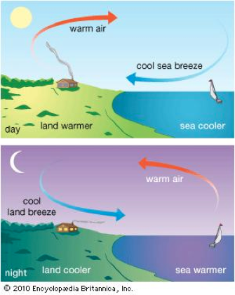
i. Can change over decades and hundreds of years.
ii. What can be typically expected
iii. Extremes are averaged into norms.

IV. Local Wind Examples
A. Sea Breeze-

B. Land Breeze-

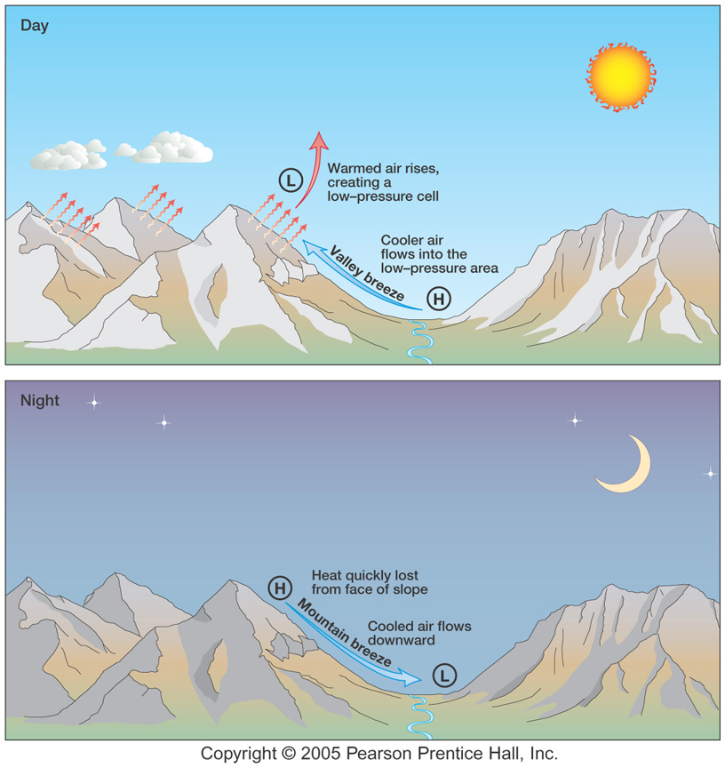
C. Valley Breeze-

D. Mountain Breeze-

V. How does Air move across the Globe?
A. Air typically
i. forms by poles because cold air sinks.
ii. forms by equator because warm air expands, is less dense and rises.

B. BUT!!! The Earth is NOT FLAT and ROTATES West to East….So objects DO NOT move in straight lines. This is called the Coriolis Effect!!
Note: The Link above offers a great explanation!!
C. Coriolis Effect-
i. Objects deflect to the in Northern Hemisphere
ii. Objects deflect to the in Southern hemisphere
D. The Coriolis Effect affects .
i. Strength of the deflection is proportional to the speed. (Ex. Faster planes have to adjust more)
ii. The max effect occurs at .
iii. Zero effect occurs at .

VI. Global Wind Patterns
A. Winds in Earth’s Atmosphere are divided into 3 Belts:
- - 0-30* lat.
- - 30-60* lat.
- - 60-90* lat.
- 0* (equator) is also known as the
- 30* N or S latitude is also known as the
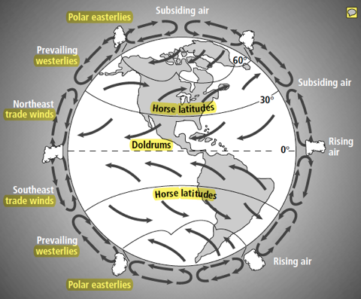
B. What impacts have global wind patterns had on history? What about climate/ecosystems?

Write a summary: What are the 4 most important “big ideas” from today?

