1. A disturbance that transmits energy and is caused by vibrations is called a ___________. Some can travel through a vacuum but others need a _____________________.

2. The ability to do work or cause change to matter is called _________________________.

3. The amount of work done when a force of 1N acts through a distance of 1m is a __________________.

4. The highest point on a wave is the _________________, while the lowest point is the _________________.

5. The _________________ of a wave is a measure of the amount of energy it carries.

6. The distance from one crest to the next crest is the _________________.

7. The _________________ is a measure of the number of waves that pass a point in a given amount of time.

8. The illustration to the right shows a wave. Label each part in the space below:
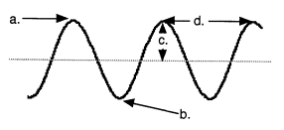
a. ____________________

b. ____________________

c. ____________________

d. ____________________

9. True or False: Waves are created by a vibration. _________________
10. True or False: An ocean wave will transport ocean water from near the middle of the ocean to the shore. _________________
11. True or False: All waves can be travel in a vacuum. _________________
12. Draw a diagram that shows how a wave/energy travels in a medium. (Think about the drop of water.)

Use the diagrams of waves drawn below to answer the following questions.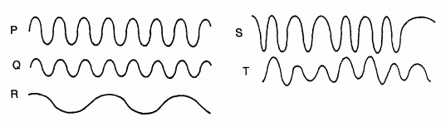

13. Waves P and Q have the same ___________________, but wave P has twice the ________________ of wave Q.
14. Waves Q and R have the same _________________, but wave R has twice the ________________ of wave Q.
15. Wave ________ shows a steady frequency but changing amplitude.
16. Wave ________ shows stead amplitude but changing frequency.
17. Waves ______ and _______ have a low amplitude and a steady frequency.

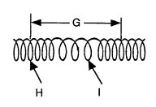
**18. The following questions refer to the diagram to the right:
a. Is this wave transverse or longitudinal? How do you know?

b. Which way does the medium vibrate in relation to the energy?

c. Letter H represents _____________________
d. Letter I represents ______________________
e. Letter G represents _____________________

**19. What is the difference between a transverse and a longitudinal wave?

