Ecosystems Study Guide
The ecology test is Tuesday, October 23rd. This study guide contains vocabulary and concepts you need to know and be able to use in examples. I have done my best to include all the general topics. The test will be a combination of multiple choice, matching, short response, and long response questions. In addition to the study guide; you can use your notes, vocabulary, homework, DA, and labs to help you study. If you have any questions ask early!!

- What is ecology?

- Compare Biotic and Abiotic. What are the main abiotic factors?

- Explain how biotic factors in the environment depend on and are impacted by abiotic factors.

- Explain and Give Examples of the Levels in an Ecosystem. (Hint make a chart)

- What is the main source of energy for life on Earth?

- Compare Autotrophs and Heterotrophs. Be able to give examples of each.

- What are 3 types of consumers? What do they eat?

- How do producers obtain energy?

- How do decomposers obtain energy?

- What is a scavenger?

- What is the unit of heat energy used to measure energy in food? How many food Calories do you need per day?

- Be able to read, make, and analyze a Food Chain, Food Web, and Energy Pyramid.
  - Where do the arrows point in a Food Chain/Web?
  - -What does a Food Web Show? What does the Energy Pyramid show?
  - -As you move up an Energy Pyramid what happens to the available energy?
  - As you move up the Energy Pyramid what happens to the number of organisms?
  - What is the 90-10 rule?
  - Be able to idently the producers and consumers in a food web and in the energy pyramid.

- What is the difference between a habitat and a niche? Give an example.

- What is the difference between predator and prey?

- What are 4 methods of studying a population? Give an example of each.

- When is it good to use random sampling? When is it good to use direct observation? When is it good to use Mark-and-Recapture?

- Ryan wants to know the number maple trees in the woods. He divides the area into 9 sections and counts trees in 4 randomly chosen sections. The data collected is 5, 7, 3, 1. What is Ryan’s estimate for the number of maple trees in the woods?

- How does a population grow in size? (2 ways)

- How does a population decrease in size? (2 ways)

- What is limiting factor?

- What is carrying capacity?

- What are factors that determine carrying capacity of an ecosystem?
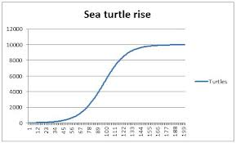
- What is the carrying capacity of the turtle population?

- How are carrying capacity and limiting factors related?

- What is an adaptation?

- Give examples of structural adaptations.

- Give examples of behavioral adaptations.

- Can an individual adapt? Why or why not?

- What are the three types of interactions among organisms?

- What is symbiosis?

- Define the three types of symbiosis. How are each of the organisms affected? (Hint make a chart)

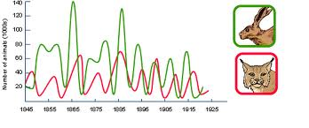
- What is the pattern of the populations shown in this graph? What is the relationship between the organisms?

