I. Prior Knowledge Questions:

A. What are two kinds of reproduction?

B. A(n) is the most basic unit of all living things.

C. Parts of a cell are called .

D. A(n) is an organism whose cells have a nucleus.

E. Only plant cells have a(n) .

F. The genetic code required for life is called .

- II. Reproduction: 2 Types of Reproduction

A. - New organism is produced from 1 parent’s genetic material.

Examples:

B. - New organism is produced from 2 parent’s genetic material.

Examples: Humans

III. Reproduction is the Foundation of Genetics

A. Genetics-

B. Heredity-

IV. Cell Growth and Division

A. All cell have a life cycle. The three steps of the life cycle are:

1. Interphase

2. Mitosis

3. Cytokinesis

B. You have two different types of cells in your body.
- Body Cells (Somatic)
- Sex Cells (Gamates)

C. Birth, Growth, Development, and Death are all part of the Cell Cycle

D. Cells are constantly reproducing to create new cells and replace ones that you have lost.

V. Mitosis-

B. Used for making:

C. Each nuclei has the same number and type of chromosomes as the original parent cell.

D. Why is it important? -

VI. Meiosis-

B. Used for making:

C. This takes one parent cell and makes 4 daughter cells that have ½ the amount of DNA as the parent.

D. Why is it important? -

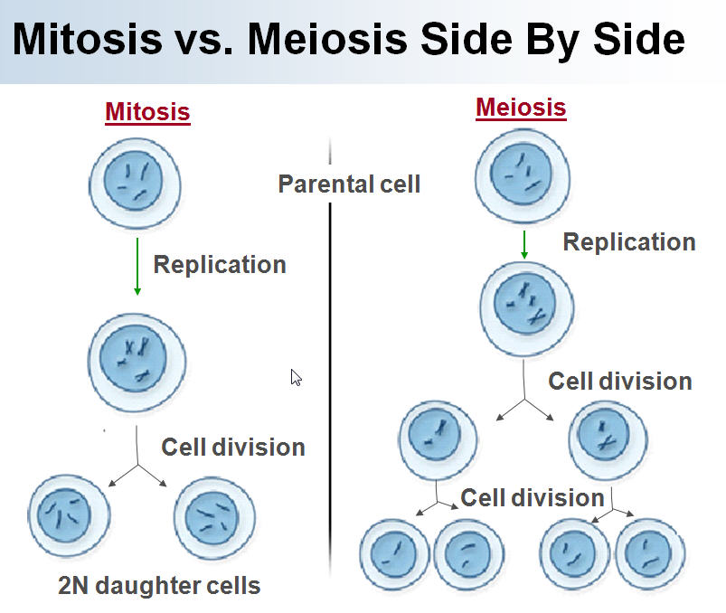

VII. Chromosomes

A. Chromosomes- structure in the nucleus that contains the DNA and proteins.

B. Diploid- A cell that has two of every kind of chromosome (2n)

1. “think double”- most cells are diploid

2. Humans have 46 chromosomes in every body cell.

C. Haploid- A cell with just one chromosome from each pair (n)

1. Human sex cells have 23 chromosomes.

Homework: Create a Venn Diagram comparing and contrasting Mitosis and Meiosis with at least 6 bullets total.

Mitosis | Both Mitosis and Meiosis | Meiosis

Review Questions: Check to see if you got the lesson.
- What are the two types of Reproduction?
- What are 3 examples of reproduction where only 1 parent is involved?
- Why is mitosis important?
- How do organisms make more sex cells?
- Why is it important that sex cells have half the DNA of a body cell?

