Ocean Currents and Climate
Essential Question: Do ocean surface currents influence climate, and if so, how do they affect it?

Objectives/Learning Goals:
- Students will create climographs for costal cities.
- Students will describe how ocean surface currents affect climate on land.

Background/Predictions:
Look at the map of below and locate the following costal cities. Write a prediction describing the climate you would expect of each place listed below. (The symbols are to help locate the cities on the world map.) Which ocean current is closest to the cities and may impact the climate at that location?

Symbol | City | Climate Prediction | Closest Current
 | Arica, Chile
 | Rio de Janerio, Brazil
 | Trondheim, Norway
 | Nuuk, Greenland
 | San Francisco, CA, USA
 | Tokyo, Japan

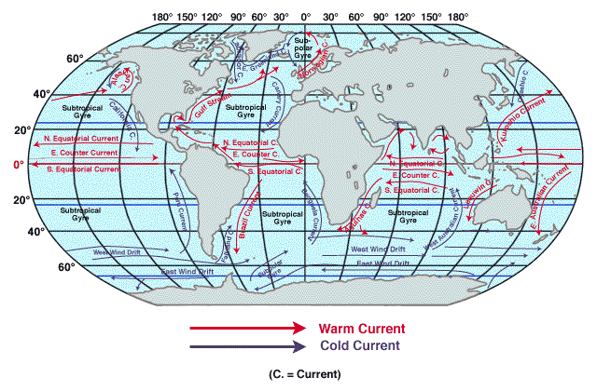
Procedure: Use the data and worksheet provided to make a climograph of one city. Then we will compare the data of the cities and analyze the climates in each region. Answer the analysis questions in the Google Form on SWS.
Name _________________________________________________________________

Using the climate data for your city, create a climograph to show the average yearly temperature and precipitation. Use a line graph for temperature and a bar graph for precipitation on the same graph. The temperature scale is on the left, precipitation on the right.

 |  |  |  |  |  | Climograph
 |  |  |  | City: |  |  |  | Latitude Location:
 | 100 |  |  |  |  |  |  |  |  |  |  |  |  |  | 100
F | 95 |  |  |  |  |  |  |  |  |  |  |  |  |  | 95
 | 90 |  |  |  |  |  |  |  |  |  |  |  |  |  | 90
E | 85 |  |  |  |  |  |  |  |  |  |  |  |  |  | 85 | P
R | 80 |  |  |  |  |  |  |  |  |  |  |  |  |  | 80 | R
U | 75 |  |  |  |  |  |  |  |  |  |  |  |  |  | 75 | E
T | 70 |  |  |  |  |  |  |  |  |  |  |  |  |  | 70 | C
A | 65 |  |  |  |  |  |  |  |  |  |  |  |  |  | 65 | I
R | 60 |  |  |  |  |  |  |  |  |  |  |  |  |  | 60 | P
E | 55 |  |  |  |  |  |  |  |  |  |  |  |  |  | 55 | I
P | 50 |  |  |  |  |  |  |  |  |  |  |  |  |  | 50 | T
M | 45 |  |  |  |  |  |  |  |  |  |  |  |  |  | 45 | A
E | 40 |  |  |  |  |  |  |  |  |  |  |  |  |  | 40 | T
T | 35 |  |  |  |  |  |  |  |  |  |  |  |  |  | 35 | I
 | 30 |  |  |  |  |  |  |  |  |  |  |  |  |  | 30 | O
 | 25 |  |  |  |  |  |  |  |  |  |  |  |  |  | 25 | N
 | 20 |  |  |  |  |  |  |  |  |  |  |  |  |  | 20
 | 15 |  |  |  |  |  |  |  |  |  |  |  |  |  | 15
 | 10 |  |  |  |  |  |  |  |  |  |  |  |  |  | 10 | in
 | 5 |  |  |  |  |  |  |  |  |  |  |  |  |  | 5
 | 0 |  |  |  |  |  |  |  |  |  |  |  |  |  | 0
 |  | J | F | M | A | MY | JN | JL | AU | S | O | N | D
 |  |  |  |  |  | Months of the Year
Climate Data
Trondheim, Norway Latitude 63.4 N Longitude 10.4 E

Average Precipitation for Trondheim, Norway (inches)
Jan | Feb | Mar | Apr | May | Jun | Jul | Aug | Sep | Oct | Nov | Dec
2.1 | 1.6 | 2.8 | 2.0 | 1.8 | 2.7 | 3.0 | 3.5 | 3.5 | 2.5 | 3.0 | 5.5

Average Temperature for Trondheim, Norway (ºF)
Jan | Feb | Mar | Apr | May | Jun | Jul | Aug | Sep | Oct | Nov | Dec
25 | 27 | 32 | 39 | 46 | 54 | 57 | 57 | 50 | 43 | 34 | 30

Nuuk, Greenland Latitude 64.2 N Longitude 51.7 W
Average Temperature for Nuuk, Greenland (°F)
Jan | Feb | Mar | Apr | May | Jun | Jul | Aug | Sep | Oct | Nov | Dec
18.7 | 18 | 17.6 | 25 | 33.1 | 39 | 43.7 | 43 | 38.3 | 30.9 | 25 | 20.8
Average Precipitation for Nuuk, Greenland (inches)
Jan | Feb | Mar | Apr | May | Jun | Jul | Aug | Sep | Oct | Nov | Dec
1.6 | 1.9 | 2.1 | 1.9 | 2.3 | 2.5 | 3.4 | 3.6 | 3.6 | 2.9 | 3 | 2.2

Arica, Chile Latitude 18.5 S Longitude 70.3 W
Average Precipitation for Arica, Chile (inches)
Jan | Feb | Mar | Apr | May | Jun | Jul | Aug | Sep | Oct | Nov | Dec
0 | 0 | 0 | 0 | 0 | 0 | 0 | 0 | 0 | 0 | 0 | 0
Average Temperature for Arica, Chile (ºF)
Jan | Feb | Mar | Apr | May | Jun | Jul | Aug | Sep | Oct | Nov | Dec
74 | 74 | 73 | 69 | 66 | 63 | 62 | 62 | 63 | 65 | 68 | 71

______________________________________________________________________________________

Rio de Janerio, Brazil Latitude 22.9 S Longitude 43.2 W
Average Temperature for Rio (°F)
Jan | Feb | Mar | Apr | May | Jun | Jul | Aug | Sep | Oct | Nov | Dec
79.2 | 79.7 | 78.8 | 76.1 | 73.4 | 70.7 | 70.3 | 71.2 | 71.2 | 73 | 75.6 | 77.4

Average Precipitation for Rio (inches)
Jan | Feb | Mar | Apr | May | Jun | Jul | Aug | Sep | Oct | Nov | Dec
4.7 | 4.3 | 4.2 | 5.6 | 3.5 | 3.3 | 2.3 | 2.1 | 3.6 | 3.6 | 3.9 | 6.9
San Francisco, CA, USA Latitude 37.7 N Longitude 122.4 W
Average Temperature for San Francisco (°F)
Jan | Feb | Mar | Apr | May | Jun | Jul | Aug | Sep | Oct | Nov | Dec
51.3 | 53.9 | 55.1 | 56.2 | 57.6 | 59.6 | 60.3 | 61.6 | 62.7 | 61.5 | 56.6 | 51.6

Average Precipitation for San Francisco (inches)
Jan | Feb | Mar | Apr | May | Jun | Jul | Aug | Sep | Oct | Nov | Dec
4.5 | 4.45 | 3.25 | 1.46 | 0.7 | 0.16 | 0 | 0 | 0.21 | 1.12 | 3.16 | 4.56

Tokyo, Japan Latitude 35.7 N Longitude 139.7 E
Average Precipitation for Tokyo, Japan (inches)

Jan | Feb | Mar | Apr | May | Jun | Jul | Aug | Sep | Oct | Nov | Dec
2.0 | 2.8 | 4.2 | 5.1 | 5.7 | 6.9 | 5.3 | 5.8 | 8.5 | 7.6 | 3.8 | 2.1

Average Temperature for Tokyo, Japan (ºF)

Jan | Feb | Mar | Apr | May | Jun | Jul | Aug | Sep | Oct | Nov | Dec
42 | 43 | 48 | 57 | 65 | 71 | 77 | 81 | 74 | 64 | 55 | 47

