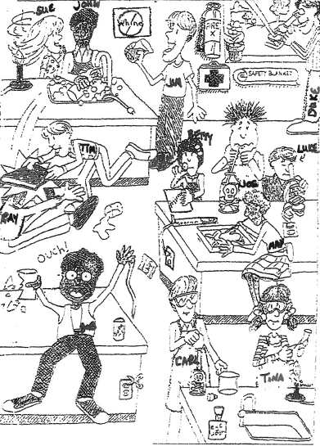
Lab Safety Questions
(5) 1.Color/Circle 5 unsafe activities shown in the illustration red. Explain why each is unsafe.

(3) 2.Color/Circle 3 correct lab procedures blue. Explain what the kids are doing right.

(3) 3.Color/Circle 3 items that are there for the safety of the students in the lab purple.

(3) 4. Color/Circle 3 things shown in the lab that should not be there green.

(2) 5.Compare Luke and Duke’s Lab techniques. Explain who is at risk of injury and why.

(1) 6.Compare Joe and Carl’s lab techniques. Explain who is doing it the correct way.

(1) 7.What will happen to Ray and Tim?

(1) 8.What is John doing wrong?

(1) 9.What should Sue have done to avoid an accident?

