Object Name | Used for | Pictures (Not to scale)
 | Used to seal glass containers  (Two items) | 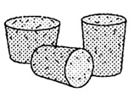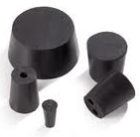
 | Used to pick up or hold hot objects | 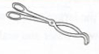
 | A wide-mouthed container used to transport, heat or store substances | 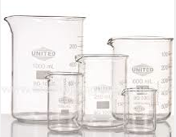
 | A device used to measure the mass or “mass out” an object or substance  (Two items) | 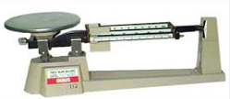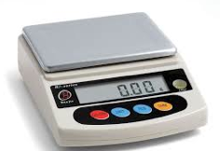
 | Protects the scientists and the scientists’ clothes from hazardous or hot chemicals (Two items) | 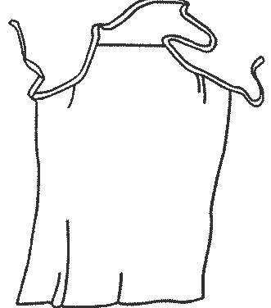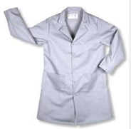
 | A small glass container used to view chemical reactions or to heat small amounts of a substance. | 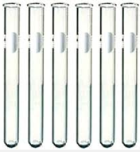
 | Used to magnify very small objects | 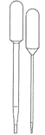  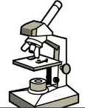
 | Used to dispense a very small amount of a liquid, sometimes measured
 | Used to light a Bunsen Burner | 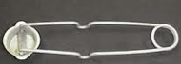
 | Protects eyes from objects getting into them | 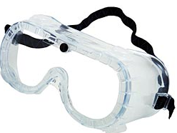
 | Attaches to a lab stand and used to hold a lab equipment (ex. Holds a funnel) | 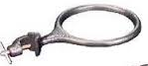
 | Used to measure volume very precisely | 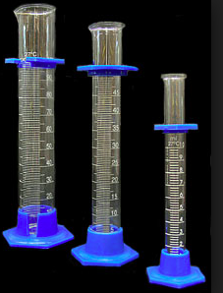
 | Steady base and support used to hold a variety of lab equipment elevated | 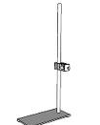
Used to hold “specimen” or samples that you want to magnify and view

(Two parts with different names)
 | Used to gently mix solutions | 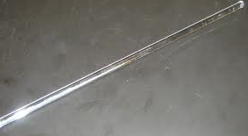
 | Used to measure temperature | 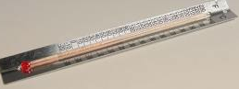
 | Used to pour liquids into containers with small openings or to hold filter paper. | 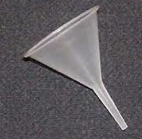
 | Used to heat objects  (Two items) | 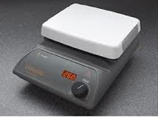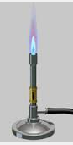
 | Used to keep test tubes upright while cleaning or experimenting | 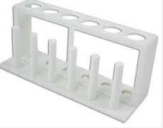
 | A narrow-mouthed container used to transport, heat or store substances, often used when a stopper is required | 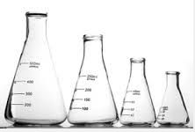
 | Used to carry/handle test tubes, especially when heating | 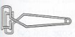
 | Containers sterile water used to clean items or add water to mixtures | 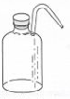
 | Used to crush or grind items | 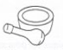
 | Used for measuring smaller distances/lengths.
 | Used to hold small amounts of liquids or specimens for study or comparison. Usually numbered or lettered. | 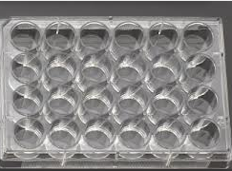
How do you measure?

 | Tools | Units | SI Base Unit
Mass
Volume
Distance
Temperature

Accuracy-
  - Ex. You look at a stream and estimate that it is 1m to the other side. You measure the width the best you can without getting wet and find it is 1.32m. Later you find out that it actually measure 1.14m. Your estimate was more accurate that your measurement.

Precision-

  - EX. Measurements made with a ruler with cm and mm is more precise than a ruler with only cm.

Displacement-

Meniscus-

