Station 1:
- Place a small piece of wax in the small pit at the end of each tine.
  - (A = Aluminum, B = Bronze, S = Steel, N = Nickel, C = Copper)
- Heat the center of the conduction device and observe the rate at which each of the pieces of wax melts.

Prediction: Which metal(s) will melt the wax the fastest? Why?
- Which metal tine melted the wax the quickest and slowest?
- Why did the different metals melt the wax at different rates?
- Explain how the thermal energy was transferred in the device. (Include a diagram)
What did you learn about How Heat Moves ?

Station 2:
- Carefully light the candle. Hold the sides of the gauze. Place the wire gauze over the flame and lower the wire gauze half way down the flame. Observe the flame and the gauze. Put out the candle.
- Next carefully light the Bunsen burner. Hold the sides of the gauze. Place the wire gauze over the flame and lower the wire gauze half way down the Bunsen burner flame. Observe the flame and the gauze. Turn off the gas to the burner.

- Does the flame burn through the holes of the wire gauze? Why or why not?
- What happens to the temperature of the wire gauze if you hold it in the flame for a while?
- How does holding the gauze over the Bunsen burner differ from the candle? Why?
- What would happen to the flame on the candle if you went back and held it over again after the burner? Why?
What did you learn about How Heat Moves?

Station 3:
- Begin heating 200-ml of water (or obtain 200ml of hot water.)
- Assemble the materials as shown in the diagram below. Be sure to select thermometers that read the same temperature to start. (or adjust your measurements.)
- Fill one cup with cold water and the other with hot water. Quickly cover both cups.
- Observe the temperature of the two cups for 5 minutes. Make a data table.
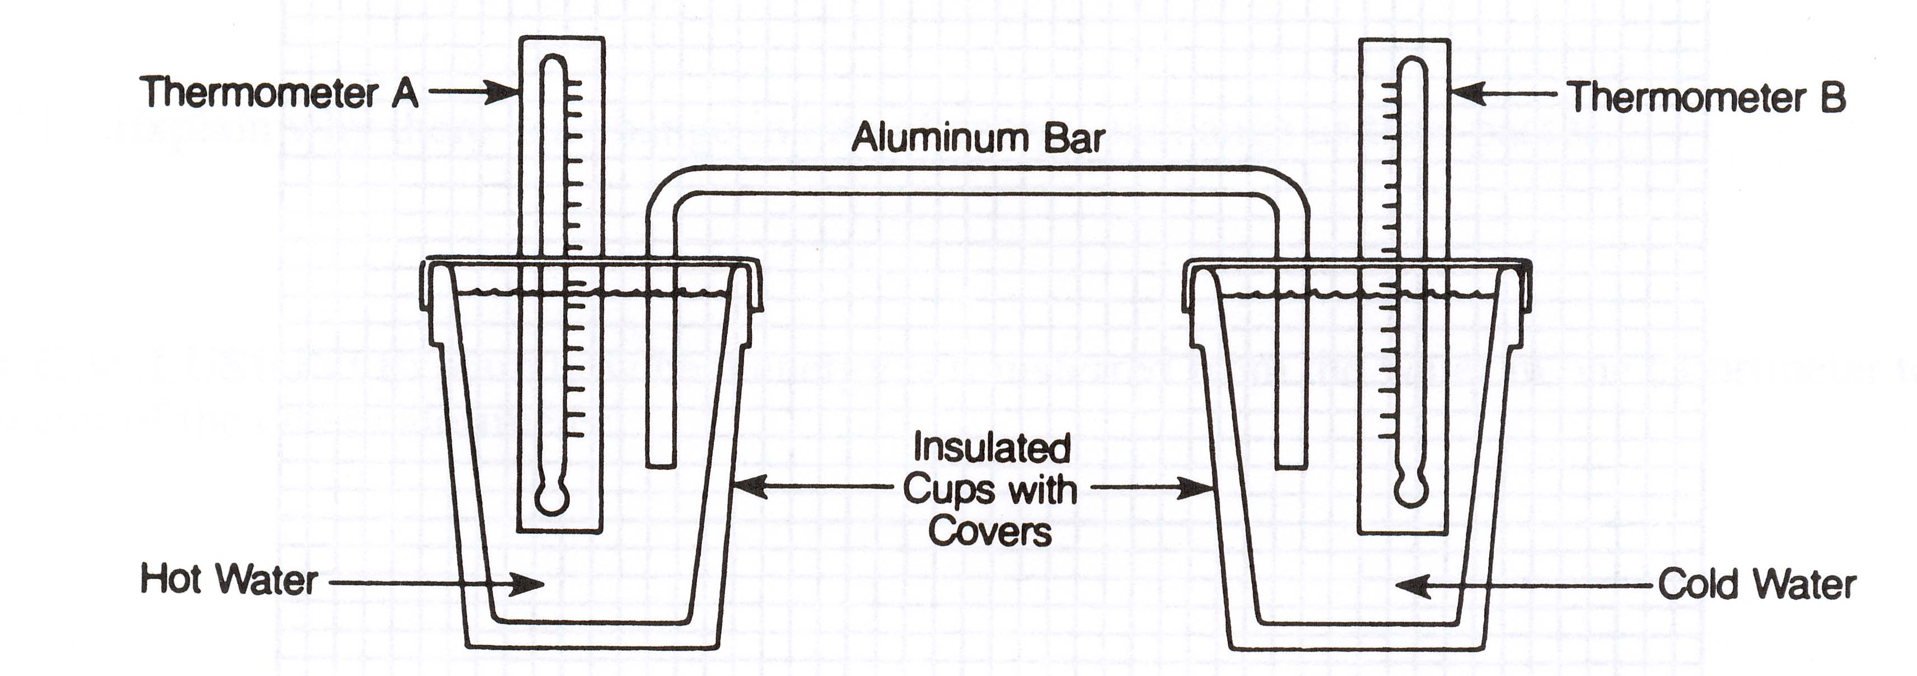
8. What happened to the temperature of the hot cup of water and the cool cup of water?
9. What does this indicate about the direction in which the heat flows in this system?
10. What was the method of heat transfer in this system?
11. How would the results change if the aluminum bar were replaced with a bar of another metal? How would the results change if the aluminum bar were replaced with plastic?
What did you learn about How Heat Moves?

Station 4:
Ice cube
- Fill a beaker with room temperature water.
- Place an ice cube with food coloring into the beaker of water and observe.

- What happens to the food coloring in the ice cube when it starts to melt?
- Why does this happen?

Tank
- Heat 1000-ml of water on high for 10 minutes. (or obtain water from Mrs. Spence)
- Fill another 1000-ml beaker with ice water.
- Place the container with 3000-ml of water onto of the beakers with the hot water at one end and the cold water at the other.
- Drop red food coloring in the hot side of the container and blue food coloring into the cold side of the container.
- Observe what happens.

Prediction: What will happen to the red food coloring that you drop into the warm side of the container? What will happen to the blue food coloring that you drop into the cold side of the container?
- Describe what happens to the red food coloring that you drop into the warm side of the container of water.
- Describe what happens to the blue food coloring that you drop into the cool side of the container of water.
- Why does this happen?
What did you learn about How Heat Moves ?

Station 5:
- Point the light at the radiometer from about one meter away. Observe.
- Move the light source closer to the radiometer. Observe.

- What is causing the radiometer to turn?
- Through what method is heat transferred to the radiometer?
- When you move the light closer to the radiometer what happens?
- Which way does the radiometer turn?
- Based on the colors of the panels, why do you think the radiometer turns this way?
What did you learn about How Heat Moves?

Station 6:
- Read the article on Radiation.
- Using the materials provided calculate your Personal Radiation Exposure. Then answer the questions below using the documents provided.
- What is your annual radiation exposure in mSv?
- How do you think your annual radiation dose will compare to your classmates and teacher? What leads you to that conclusion?
- Why should humans be concerned about radiation on Earth?
- Identify groups of people who may be more concerned about radiation than others.
- How does your radiation exposure compare to an astronaut’s exposure, and why?
- How could you reduce the amount of radiation you are exposed to?
- Describe three things that affect the magnitude of a radiation does.

This is the schedule for our 3-day lab. It is important that every day’s work is completed on that day in the order listed. If you do not finish questions on that day you MUST finish them for homework that night. I will be doing 3-point checks as you go along and you will get points for being on task and safe with each lab. Station 6: Is to be completed when you have time on any day.

 | Group 1 | Group 2 | Group 3 | Group 4 | Group 5 | Group 6
Day 1 | Station 4 | Station 4 | Station 3/5 | Station 5/3 | Station 1/2 | Station 2/1
Day 2 | Station 1/2 | Station 2/1 | Station 4 | Station 4 | Station 3/5 | Station 5/3
Day 3 | Station 3/5 | Station 5/3 | Station 1/2 | Station 2/1 | Station 4 | Station 4

