Heat Transfer and Heating in the Atmosphere

I. Background Vocabulary
Thermal Energy- the total energy of motion in the molecules of a substance
Temperature- the average amount of energy of motion of each molecule of a substance
Thermometer- tool used to measure the average amount of energy of motion (temperature)
Heat- energy transferred from a hotter object to a cooler object

II. There are 3 ways Heat is transferred
Radiation- the direct transfer of energy by electromagnet waves
Ex-
Conduction- the direct transfer of heat from one substance to another substance that is touching
Ex-
Convection- the transfer of heat by the movement of a fluid
Ex-
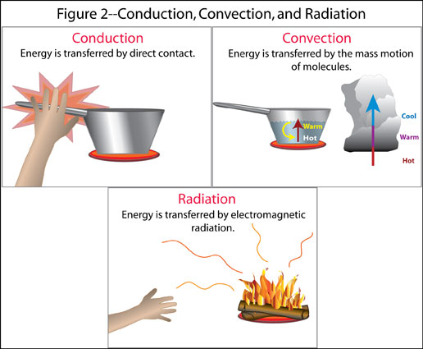

III. Apply your Knowledge
Instructions: Collect temperature data from 2 different locations on school grounds. You must get a temperature reading by placing the thermometer on the ground/surface, holding it 1 cm above the surface, and holding it 1.25 m above the surface. Allow the thermometer to adjust to each new location before taking the reading. Record qualitative observations of the surface as well.
Current Temperature:

Surface A: Location, and Description
Temperature on surface
Temperature 1 cm above surface
Temperature 1.25 m above surface
Change in Temperature (1 cm- 1.25 m)

Surface B: Location, and Description
Temperature on surface
Temperature 1 cm above surface
Temperature 1.25 m above surface
Change in Temperature (1 cm- 1.25 m)

Questions:
1. When you placed the thermometer directly on the ground what kind of heat transfer was taking place? When you placed the thermometer 1.25m above the ground what kind of heat transfer was taking place? What kind of transfer occurred for your skin to feel warm?

2. How did the temperature 1 cm above the ground compare to the temperature 1.25 m above?

3. Are there differences between your two locations? Explain. Why do you think that was or was not the case?

4. Predict the outcome of this experiment if you were 12 hours from now? Explain your Prediction using science terms.

5. What can you conclude about the temperature of the troposphere closer to the ground as opposed to further from the ground?

