I. Genetic Disorders (pg. 117-118)

A. Genetic disorder-
B. Identify two causes of genetic disorders in humans:

C. These are some common genetic disorders in humans today.
1. Cystic Fibrosis

Cause-
How do people get the disorder? -
Symptoms -
Diagnosis-
Treatment -
Incidence (How often does it happen? (Be Specific))-
2. Sickle-Cell Disease

Cause-
How do people get the disorder? -
Symptoms -
Diagnosis-
Treatment -
Incidence (How often does it happen? (Be specific)) -
3. Hemophilia

Cause-
How do people get the disorder? -
Symptoms -
Diagnosis-
Treatment -
Incidence (How often does it happen? (Be specific) -
4. Down Syndrome

Cause-
How do people get the disorder? -
Symptoms -
Diagnosis-
Treatment -
Incidence (How often does it happen? (Be specific) -
5. Huntington’s Disease

Cause-
How do people get the disorder? -
Symptoms -
Diagnosis-
Treatment -
Incidence (How often does it happen? (Be specific) -
6. Phenylketonuria (PKU)

Cause-
How do people get the disorder? -
Symptoms -
Diagnosis-
Treatment -
Incidence (How often does it happen? (Be specific) -
II. Pedigrees (pg.119)

- What is a Pedigree?
- Why are pedigrees important or How are they used?
- Symbols and Descriptions
  - Circle represents -
  - Square represents-
  - Horizontal line represents-
  - Vertical line and bracket represents-
  - Shaded all the way represents-
  - Not shaded represents-
  - Shaded half-way represents-

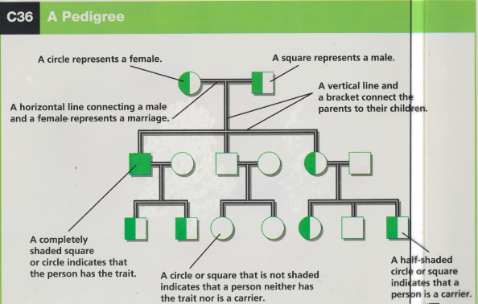

- Now try to create a pedigree using the following story.
A man and a woman marry. They have 5 children, 2 girls and 3 boys. The mother is a carrier of hemophilia, a sex-linked disorder. She passes the gene on to two of the boys who died in childhood and one daughter is also a carrier. Both daughters marry men without hemophilia and have 3 children each (2 boys and a girl). The carrier daughter has one son with hemophilia. One of the non-carrier daughter’s sons marries a woman who is a carrier and they have twin daughters. What is the percent chance that each of the twin daughters will be a carrier?

III. Genetic Advances (pg. 120-131)

- Karyotypes-
- Genetic Counseling-
- Selective Breeding-
- Cloning-
- Genetic Engineering-
- Gene Therapy-
- Human Genome Project-
- DNA Fingerprinting-

