What are the types of fungi? (at least 3)

How many cells do they have? (Describe for each kind of fungi.)

Are Fungi Prokaryotes or Eukaryotes?

How do fungi get energy?

How do fungi reproduce? (Describe for each kind of fungi)

What is a fungi’s body made of? (Body Plan of a Mushroom Fungi) | 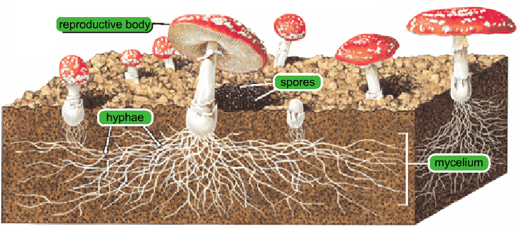  1. -top part, what is visible, contains #2  1  2  3  4  2. -small brown/black specks that fall from #1  3. -holds #1 up  4. -underground mass, makes up most of the fungi  5  5. -one individual strand, altogether makes #4
How do fungi help and harm humans?
(Give at least 2 of each.)
What are some examples of fungi?
(Give at least 4)

