Spheres of Our World
Hydrosphere-
Ex:
Lithosphere-
Ex:
Biosphere-
Ex:
Atmosphere-
Ex:
---------------------------------------------------------------------------------------------------------------------
Cycles of Matter
Cycle-
Matter-
Why is matter “recycled” but Energy was “lost”?
The Water Cycle
How does water move in the Environment?
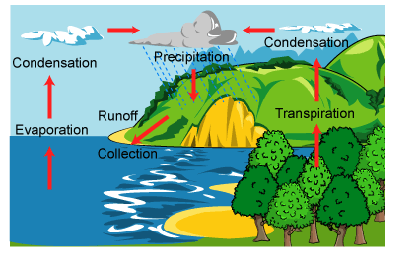
Transpiration-
The Carbon Cycle-
How does Carbon Move in the Environment?
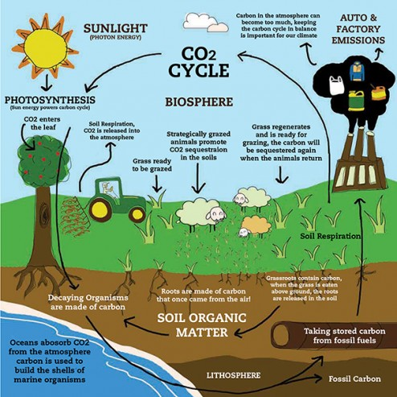
Photosynthesis-
Cellular Respiration-
Other Movements?
Sinks- areas where carbon is “stored” or “accumulates”. (Absorbs more than gives off) | Sources- areas where carbon can is released. (Gives off more than is absorbed.)

What impacts do humans have on the carbon cycle?
Greenhouse Effect-

The Nitrogen Cycle
Nitrogen is…
Most organisms get Nitrogen directly from the environment.
Nitrogen fixation-
Plants get Nitrogen by | Animals get Nitrogen by
Nitrogen is returns to the environment by

