Clouds
How are clouds formed?

Dew Point-

Types of Clouds
Cumulus-
Cumulonimbus- thunderstorm
Stratus-
Nimbostratus-rain clouds
Cirrus-

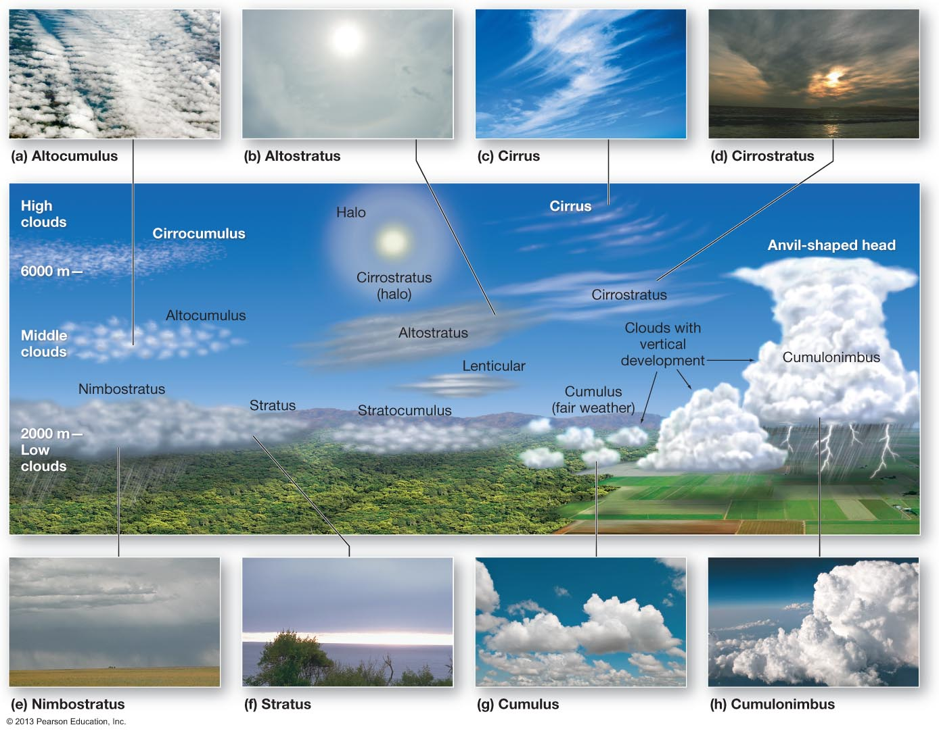

Air Masses

Air Mass-
- Defined by and
- Named based on the source region of the air mass itself
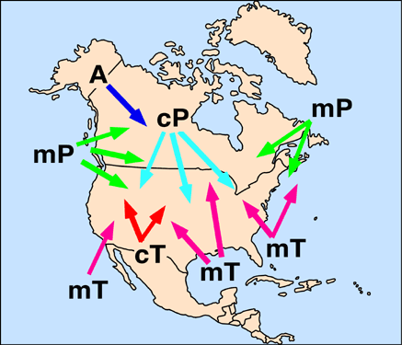

Air Mass | Abbr. | Where does it form? | Temp. | Moisture Content
Continental Polar | cP | Closer to poles over land-locked regions
Continental Tropical | cT | Closer to tropics over land-locked regions
Maritime Polar | mP | Closer to poles over water
Maritime Tropical | mT | Closer to tropics over water
Arctic | A | In the very cold land-locked areas

Fronts

Front-
- Collision of air masses causes stormy, changeable weather
- 4 Major Types of Fronts
  - Cold
  - Warm
  - Stationary
  - Occluded
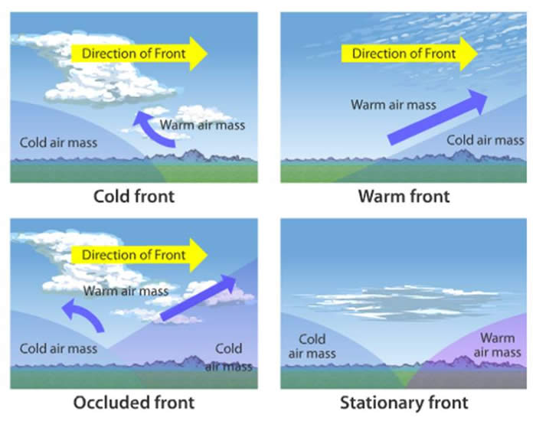

Type of Front | Symbol | How it Forms | Weather it Brings
Cold Front  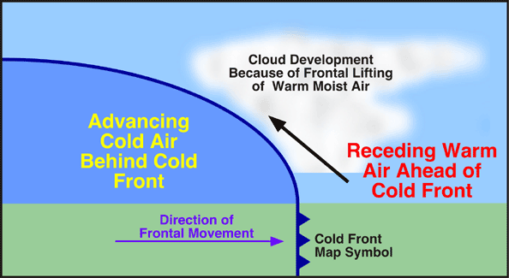 |  | Cold air pushes under a warm air mass,  Forcing the warm air to rise.  Move Quickly | clouds develop ahead of the front as warm air rises,  Cools, and condenses producing showers and thunderstorms.  weather likely to follow front.
Warm Front  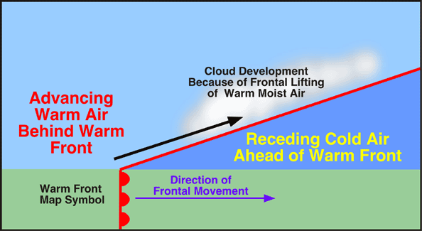 |  | Warm, moist air mass slides up and over a cold mass  Usually moves slowly brings warm humid air | As the warm air rises, the water vapor in it condenses into clouds that can produce gentle rain, snow, sleet, or freezing raining,  Followed by weather.  Associated with type clouds.
Stationary Front  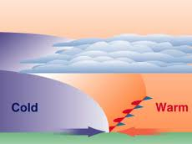 |  | When two air masses come together, but neither displaces the other  The boundary between them is referred to as a stationary front.  “Standing still” | If the front stays stalled over an area for a long time it may bring
Occluded Front  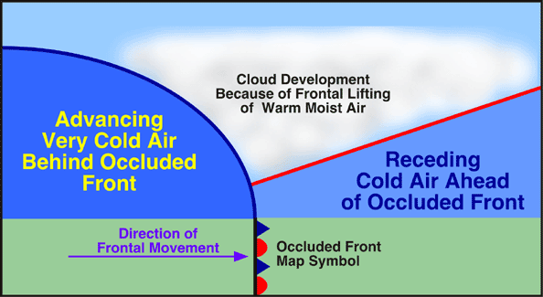 |  | The cold air mass from the cold front meets the cool air that was ahead of the warm front. The warm air rises and is trapped as these cool air masses come together in the middle.

- a swirling area of low air pressure, L, air rises, cools, forms clouds, and precipitation, rotates counter-clockwise

- a swirling area of high air pressure, H, cool air falls, dries out, rotates clockwise

Review Questions:
- What are the major types of air masses that affect weather in North America?
- How are the air masses different (what are their temp/humidity characteristics)?
- What are the main types of fronts and how are they formed?
- What weather and cloud types can be predicted with each type of front?
- How is a cyclone different than an anticyclone?

