Question: How do you know what is living?

Background: Most people feel confident that they could identify a living thing from a nonliving thing, but sometimes it’s not so easy. Scientists have argued for centuries over the basic characteristics that separate life from non-life. Some of these arguments are still unresolved. Despite these arguments, there do seem to be some generally accepted characteristics common to living things. Anything that possesses all these characteristics of life is known as an organism.

Task: Think about all the living things on Earth. What makes them all different (as a group) from non-living things? List 3-5 characteristics that make something uniquely living.

1.

2.

3.

4.

5.

Evaluate: Compare your list of characteristics with the people in your small group. Edit your lists as needed. (Talk and Share: this should be a community effort.)

Test: Does your list of characteristics work for the following items?

Characteristic | 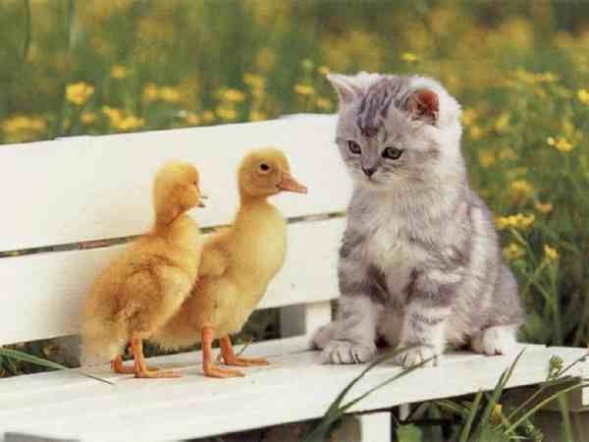  Animal | 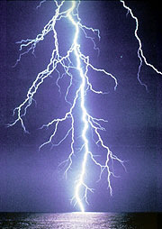  Lightening | Plant  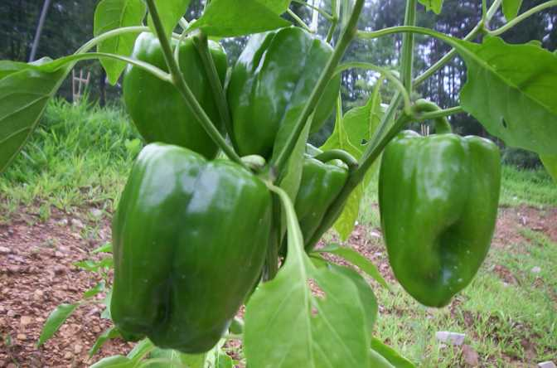 | 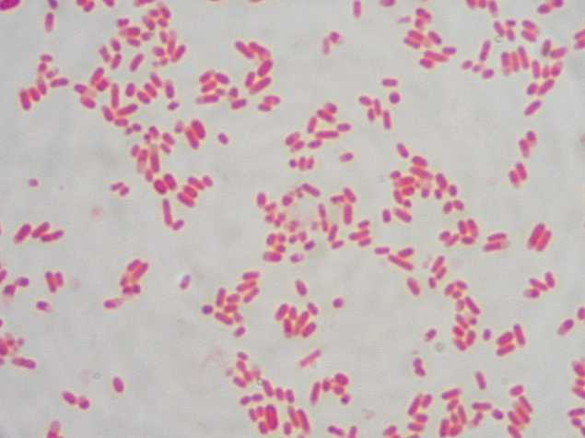  Bacteria | Water  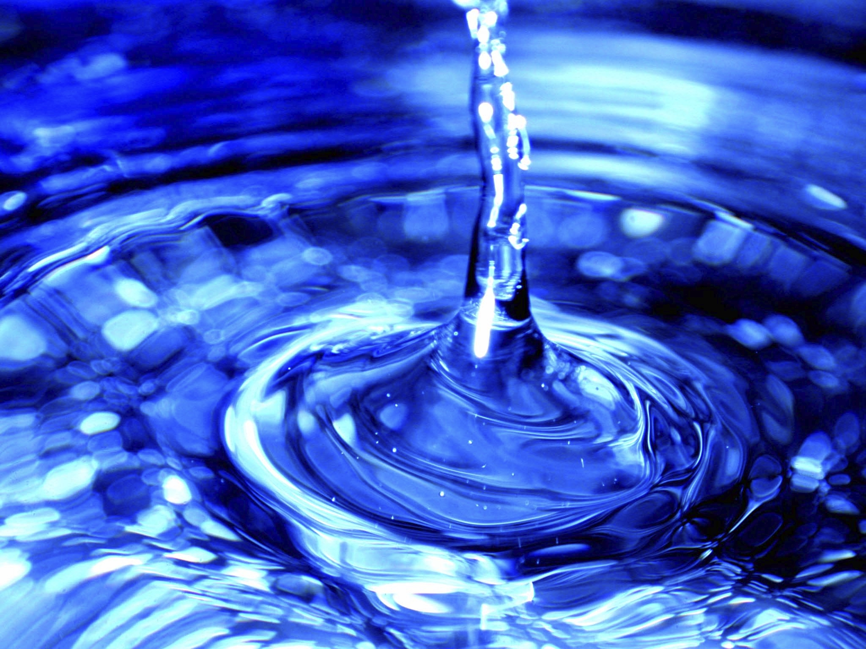
1.
2.
3.
4.
5.
Based on your characteristics is it living?

Revaluate: Does your list make sense when you apply it to specific items? After thinking about specific items in the world, reevaluate your list and make changes as a group and write your changes here.

Characteristics of Living Things Notes
A. Living things and use . ( )
B. Living things can .
C. Living things can ; their bodies are .
D. Living things can in their environment.
E. Living things can to their environment.
F. Living things are made of 1 or more .
G. Living things contain .
H. Living things maintain an internal . ( ).

Examples: Identify which characteristic of living things is being described in each of the statements below. Some statements may have more than one.
- An amoeba is unicellular organism.
- When a human steps outside in the cold, the body shivers.
- Green plants make their own food through the process of photosynthesis.
- Tim’s height has increased from 5’4” to 5’11” in three years.
- The roots of a plant grow toward a source of water.
- A baby songbird hatches from its egg with both parents are watching.
- A tulip opens up in the morning at sunrise and closes up at dusk.
- A caterpillar hibernates in a cocoon, and emerges as a butterfly.
- It is thought that chimps and humans share a common ancestor.
- It Identical twins have 99.999% of the same genes.
- A beaver is an organism composed of many different types of cells.
- A sea worm drops its tail and the tail becomes a new worm.
- As a sea worm is placed in fresh water, the pulse slows down to conserve energy.

