How does energy travel through the atmosphere? | Radiation-  Most of the energy from the sun reaches the Earth in the form of .  Some of the energy from the sun is
What is the basis for dividing the atmosphere into four layers?
Describe the layers of the atmosphere | Troposphere-  Stratosphere-  Ozone- forms a layer in the stratosphere; a pale blue gas that absorbs radiation from the Sun and protects the surface of the Earth  Mesosphere-  Thermosphere-  Ionosphere- part of the Thermosphere 80-550km, Radio waves bounce off of electrically charged molecules, contains Aurora Borealis  Exosphere- part of the Thermosphere; above 550 km, satellites orbit here | 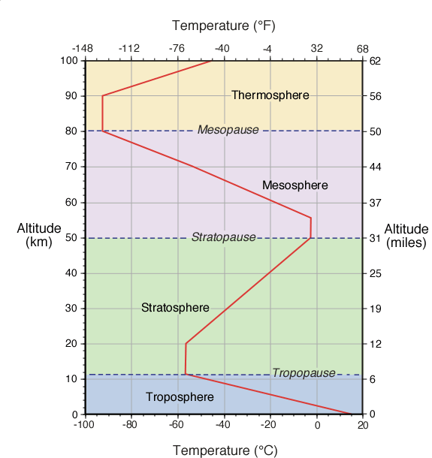
What happens to the thermal energy as you go through the layers in the atmosphere? Why? | As you increase in altitude in the Troposphere- , because  As you increase in altitude in the Stratosphere- , because  As you increase in altitude in the Mesosphere- , because  As you increase in altitude in the Thermosphere- , because
What happens to energy when it reaches Earth? | Energy on Earth is transferred between land, water, and air in 3 ways:  1. Radiation- the direct transfer of energy by electromagnetic waves Ex-  2. Conduction- the direct transfer of heat from one substance to another substance that is touching Ex-  3. Convection- the transfer of heat by the movement of a fluid Ex- | 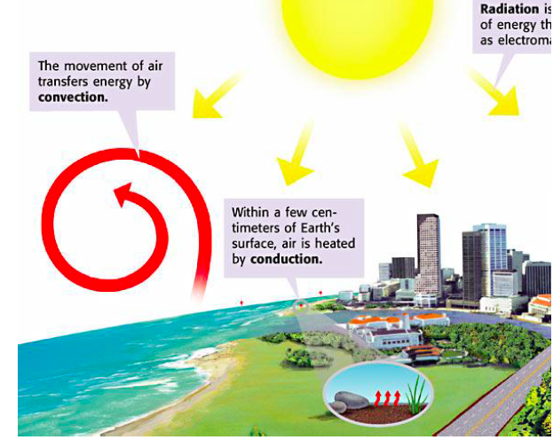
What is the atmosphere made of? | Atmosphere-  of the atmosphere is made of Nitrogen  of the atmosphere is made of Oxygen  Also Includes:
Why is the atmosphere important for life on Earth? | Three jobs of the atmosphere

What is air pressure? How does it work? | Air Pressure- the force exerted on you by the weight of particles of air.  Air Pressure is measured using .  The unit to measure air pressure is .
What can we learn from the labs yesterday? | Heavy Air- (balloons on the balance)  A Pressing Engagement-  Marshmallow Madness-
Why doesn’t air pressure crush things on Earth?
What effects air pressure? | Altitude- the height you are at above sea level  The higher the altitude, the the air pressure.  (There are less molecules above higher in the air)  The lower the altitude, the the air pressure.  Temperature- the average energy or a group of molecules or area  As the temperature , the air pressure is lower.  (Hot molecules are further apart-less pressure)  As the temperature , the air pressure is higher.  (Cold molecules are closer together-more pressure) (Cold air is more dense than warm air.)  Humidity- the amount of water or water vapor in the air.  Water vapor weighs less than air molecules.  As the air becomes more humid, the air pressure goes  (moist air weighs less than dry air)  Drier air has pressure because dry air weighs more than moist air. | 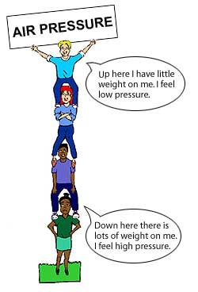  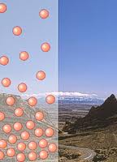  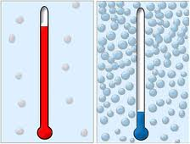

Summary/Review: Now try your hand at filling in this chart…
 | What happens to the air pressure if….  (Answer should be Higher or Lower) | Reasoning
Altitude increases
(top of the mountain)
Altitude decreases
(bottom of the mountain)
Temperature increase
(warmer)
Temperature decreases
(colder)
Humidity increases
(more water vapor)
Humidity decreases
(less water vapor)

