What is air pressure? How does it work? | Air Pressure- the force exerted on you by the weight of particles of air.  Air Pressure is measured using .  The unit to measure air pressure is .
What can we learn from the labs yesterday? | Heavy Air- (balloons on the balance)  A Pressing Engagement-  Marshmallow Madness-
Why doesn’t air pressure crush things on Earth?
What effects air pressure? | Altitude- the height you are at above sea level  The higher the altitude, the the air pressure.  (There are less molecules above higher in the air)  The lower the altitude, the the air pressure.  Temperature- the average energy or a group of molecules or area  As the temperature , the air pressure is lower.  (Hot molecules are further apart-less pressure)  As the temperature , the air pressure is higher.  (Cold molecules are closer together-more pressure) (Cold air is more dense than warm air.)  Humidity- the amount of water or water vapor in the air.  Water vapor weighs less than air molecules.  As the air becomes more humid, the air pressure goes  (moist air weighs less than dry air)  Drier air has pressure because dry air weighs more than moist air. | 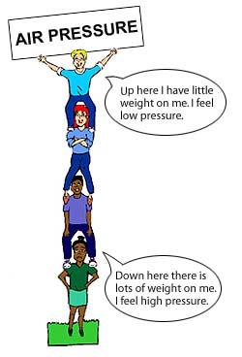  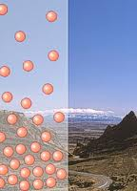  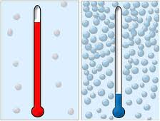

Summary/Review: Now try your hand at filling in this chart…
 | What happens to the air pressure if….  (Answer should be Higher or Lower) | Reasoning
Altitude increases
(top of the mountain)
Altitude decreases
(bottom of the mountain)
Temperature increase
(warmer)
Temperature decreases
(colder)
Humidity increases
(more water vapor)
Humidity decreases
(less water vapor)

